Axiom Requisition Copy Service
2869 Jolly Rd, Okemos, Michigan 48864
517.886.5099 – 877.886.5090 toll free – 517.886.4116 facsimile – records@axiomcopy.com

REQUEST FOR RECORDS - ORDER NUMBER 01-12022-019

TO THE CUSTODIAN OF RECORDS Date Sent: November 8, 2026
The Longstreet Clinic, PC Department of Surgery
Dept. Medical Records
725 Jesse Jewell Parkway
Gainsville, GA 30501
Please find enclosed a request for records of:
Shelley Marie Pittman
DOB 08/15/1964 SSN XXX-XX-5108
We are requesting the following:

FROM 01/15/2011 TO PRESENT: Any and all UPDATED MEDICAL records and Medicaid and Medicare BILLING records pertaining to Shelley Marie Pittman SSN: XXX-XX-5108, DOB: 08/15/1964.

INSTRUCTIONS
- FORWARD INVOICE WITH RECORDS – If fee is greater than $50.00 Pre-approval is required.
- PLEASE DO NOT STAPLE DOCUMENTS.
- Mail, email or fax the records to: Axiom Requisition Copy Service (as agent of Karen M. Faett, Siemion Huckabay, P.C.), 2869 Jolly Rd, Okemos, MI 48864 – Phone: 517.886.5099 – Fax: (517) 886-4116 – Email: records@axiomcopy.com.
SIGN AND RETURN THIS FORM WITH THE REQUESTED RECORDS
__________________________________________________________
CERTIFICATION OF RECORD SUBMISSION
I certify in response to the request issued to me, that I have submitted a true and complete copy of all requested documents in my control or possession relating to the above person; and that (A) The record was made at or near the time of the occurrence of the matters set forth by, or from information transmitted by, a person with knowledge of those matters; (B) The record was kept in the course of the regularly conducted business activity; and (C) It was the regular practice of the business activity to make the record.

_____________________________________________ _____________________
Signature of the custodian of records Date

If you are sending only part of the documents requested above and some are not in your possession, please check the appropriate boxes below:
- No Medical Records ◻ No X-Ray Films ◻ No Photographs ◻ No Billing Records
If you do not have any of the records requested, please contact our office for an affidavit of no records or send us a letter on your letterhead stating you do not have any of the records requested.

ORDER NUMBER 01-12022-019
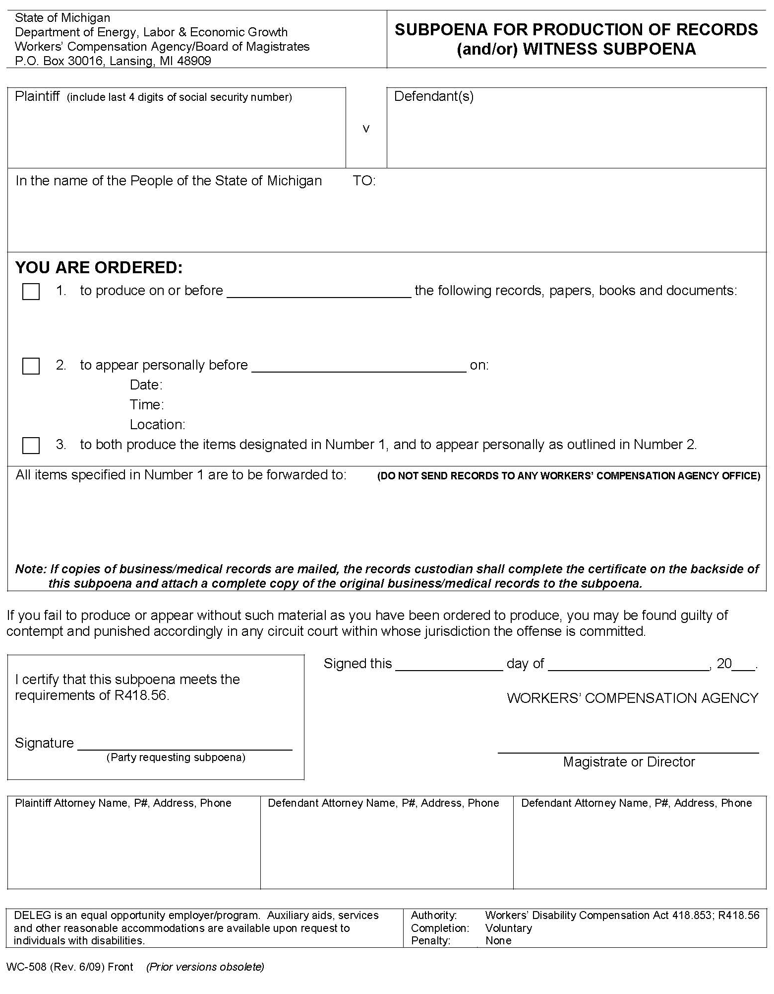
Shelley Marie Pittman, a legally incapacitated
individual, by her Next Friend and Guardian,
Beverly Pittman

Shahid Jamil, M.D.

The Longstreet Clinic, PC Department of Surgery
725 Jesse Jewell Parkway
Gainsville, GA 30501

X

FROM 01/15/2011 TO PRESENT: Any and all UPDATED MEDICAL records and Medicaid and Medicare BILLING records pertaining to Shelley Marie Pittman SSN: XXX-XX-5108, DOB: 08/15/1964.

Axiom Requisition Copy Service
2869 Jolly Rd
Okemos, MI 48864
Albert J. Dib
Dib Fagan & Brault P.C.
25892 Woodward Avenue
Royal Oak, GA 48067-0910
(248) 542-6300
Karen M. Faett
Siemion Huckabay, P.C.
One Town Square Suite 1400
Southfield, MI 48076
(248) 213-2004
Order No. 01-12022-019
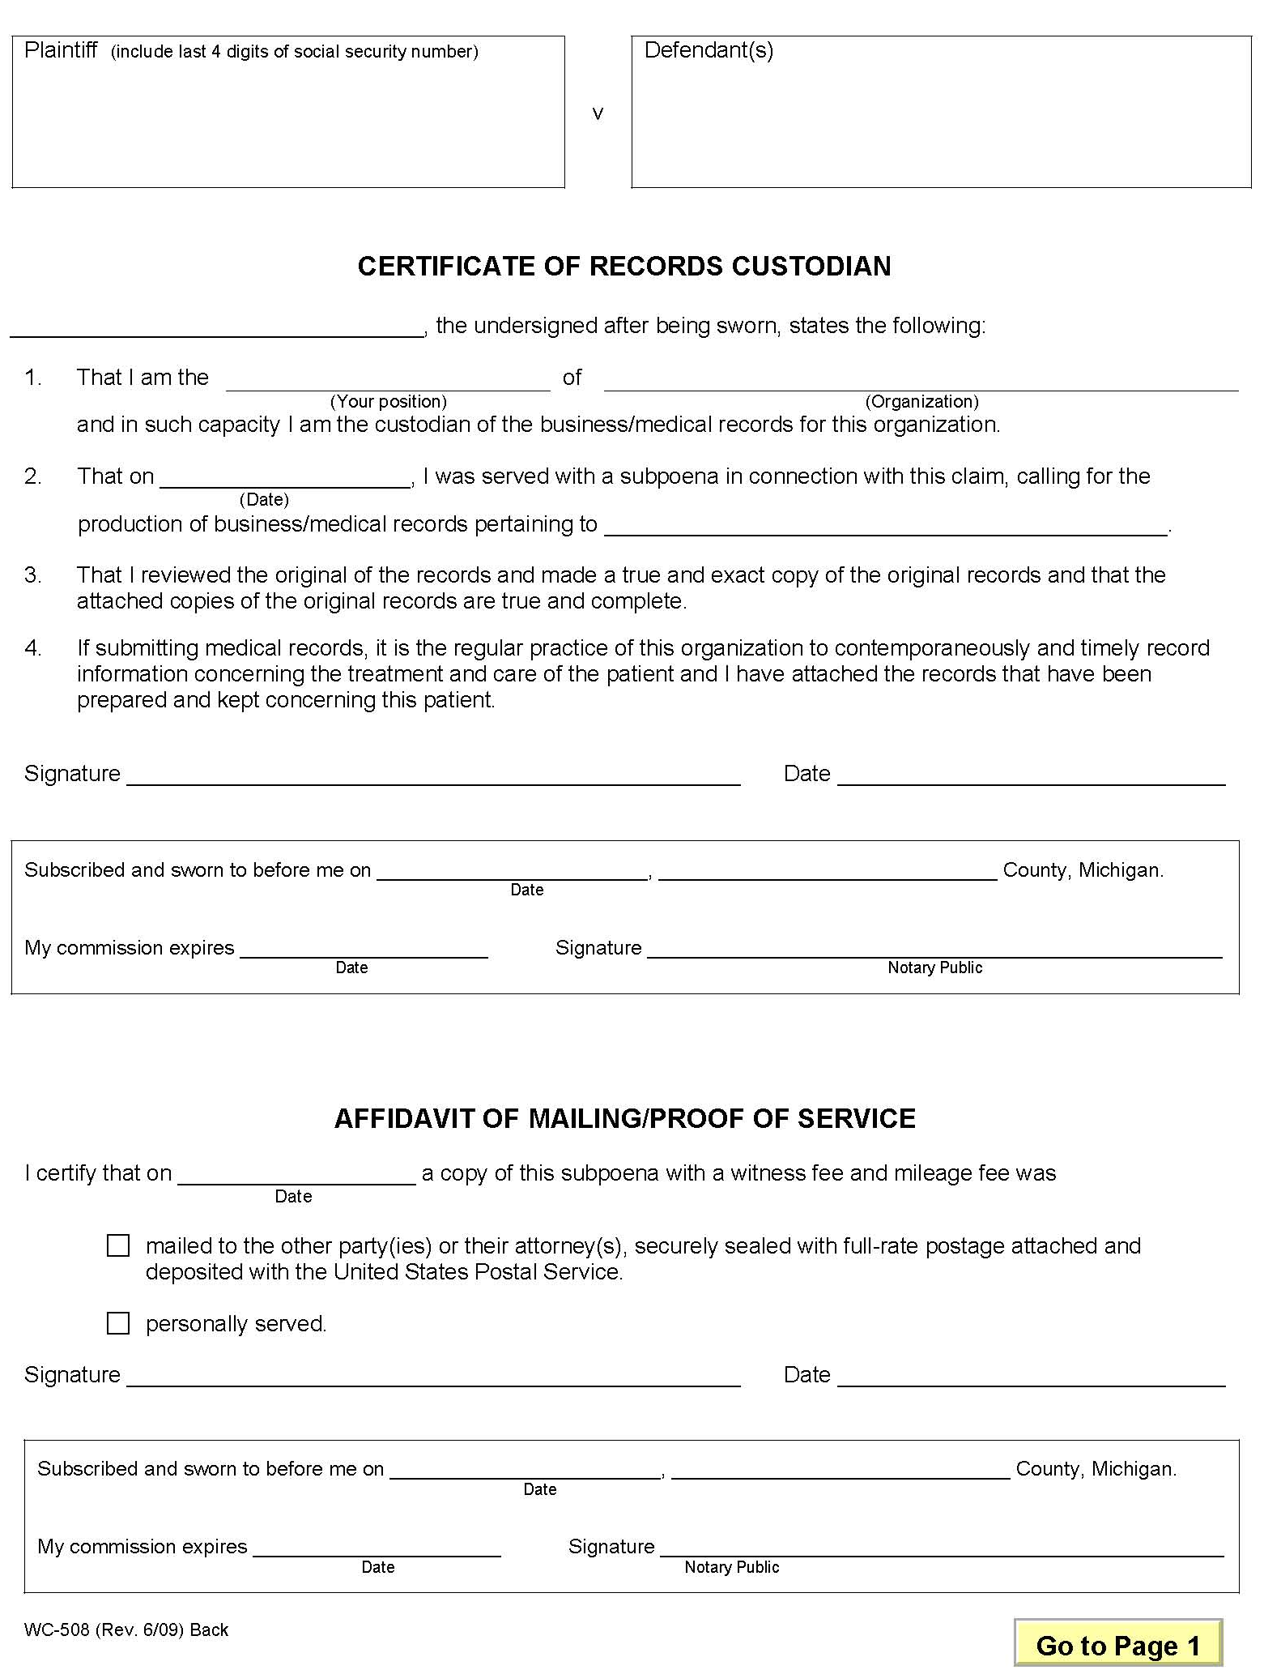

Shelley Marie Pittman, a legally incapacitated
individual, by her Next Friend and Guardian,
Beverly Pittman

Shahid Jamil, M.D.

Order No. 01-12022-019

